***Assignment – 12***

Using the operators IN, ANY, and ALL.

1. Write a query that selects all customers whose ratings are equal to or greater than ANY of Serres’.

Ans 1)

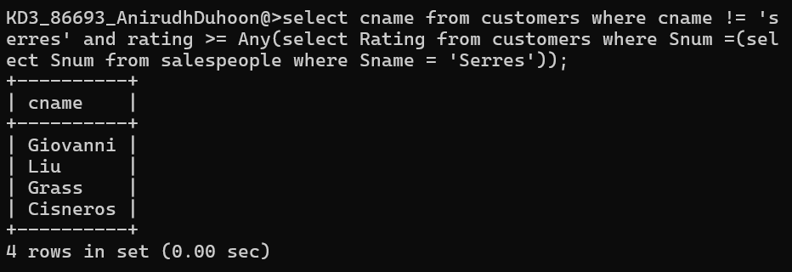

1. Write a query using ANY or ALL that will find all salespeople who have no customers located in their city.

Ans 2)

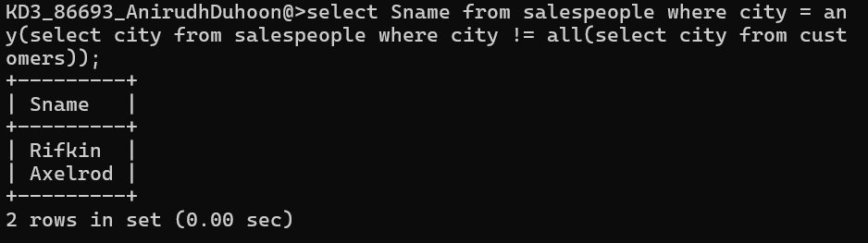

1. Write a query that selects all orders for amounts greater than any for the customers in London.

Ans 3) 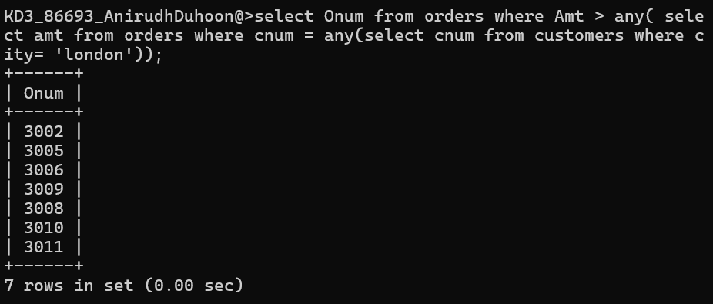

1. Write the above query using MIN or MAX.

Ans 4)

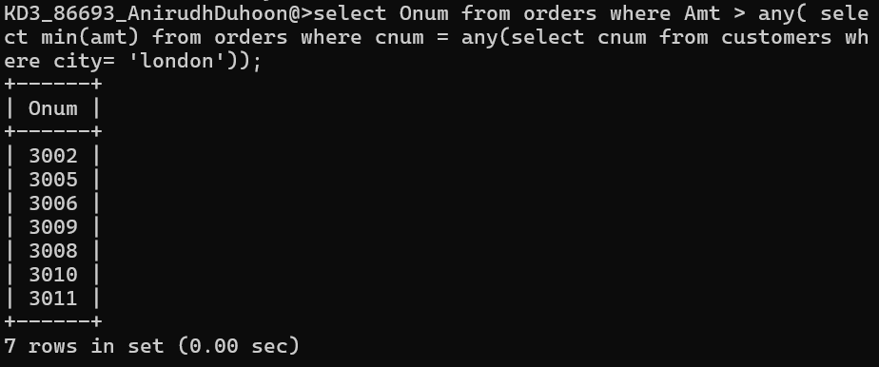

*Sameer Dehadrai* Page: 1